Course Load and Student Direction Report Q&A

Note: Data sources and processes are changing significantly. If you find data problems, let us know as soon as possible, and we can work with you to resolve.

How do I log in?
You can access the report directly by using the link below and logging in with the AD credentials that you use to access your email (leave off “@ucsd.edu”): https://tableau.ucsd.edu/#/views/CLSD1/CLSD

Can’t log in? You may need additional authorization. Please send an email to ir@ucsd.edu to submit your request. Alternatively, access https://tableau.ucsd.edu and log in with your AD credentials. Find project ``IR – Institutional Workload’’ and click on the ``Workbooks’’ tab (see below.)

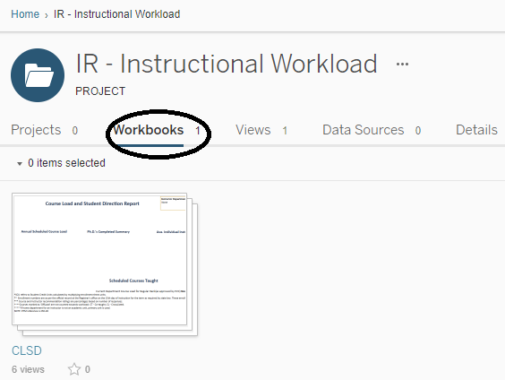

How do I use the CLSD report?

Open the report and choose Instructor Department, Instructor Name, and Years in the interactive filters in the upper right- hand corner (see below.) Note: If you change the department selection again, Instructor Name may appear in parentheses
-- (Smith, John.) This indicates that John Smith is not listed under the new department selected, and you will need to click on the Instructor Name filter again to make a valid selection.
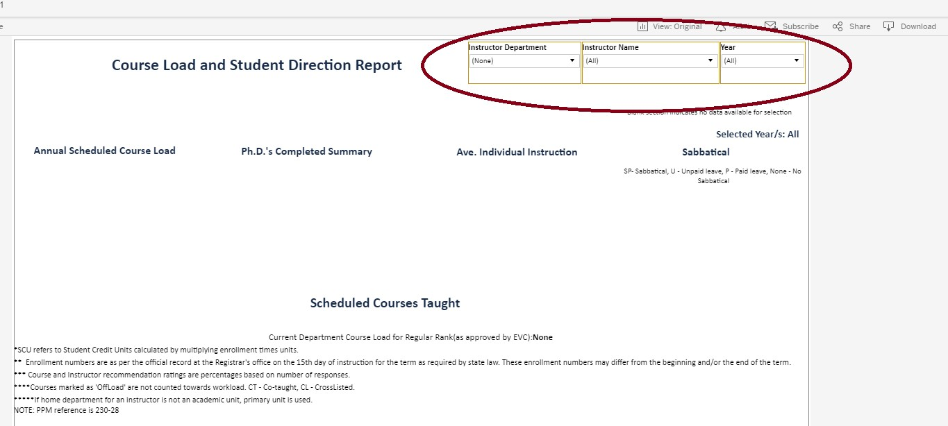

How do I make a .pdf and print the report?
After selecting an instructor, click on the Download icon in the upper right-hand corner of the Tableau Server toolbar:

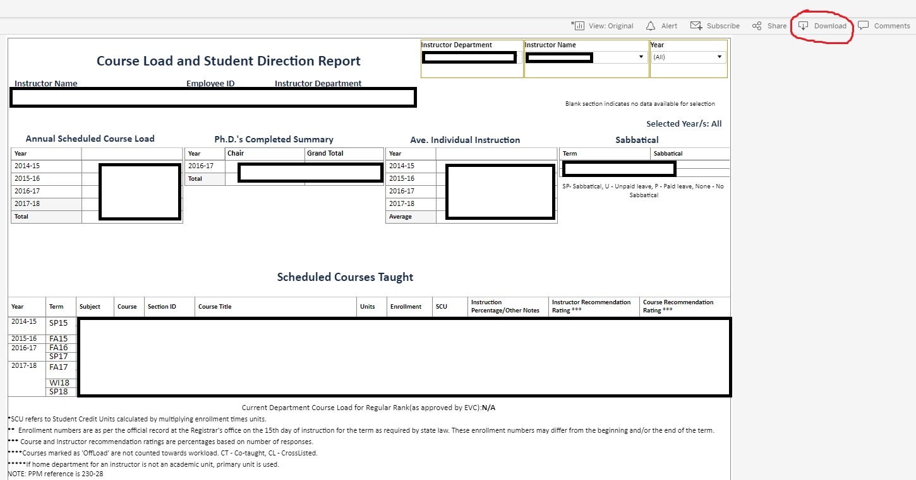
Choose to download .pdf file
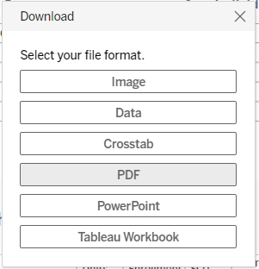
In the next menu, set Scaling to “At most 1page width” and set Page Size to “A4”, then click on Download. The settings are already adjusted to print the form in the portrait layout.

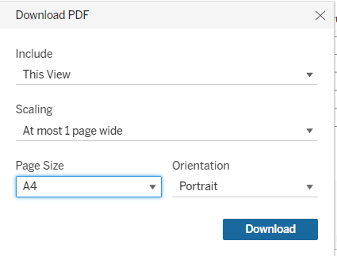
For some instructors, the report may show white space between tabs, because we have chosen a certain window size for each element of the report to make sure all records appear in full for all the instructors. Click ``download’’ on the prompt to initiate the download. You can then open the .pdf file and print it out.

- What do I do if Instructor’s scheduled course and/or individual instruction lists do not fit in the window on the form (see an example below)?

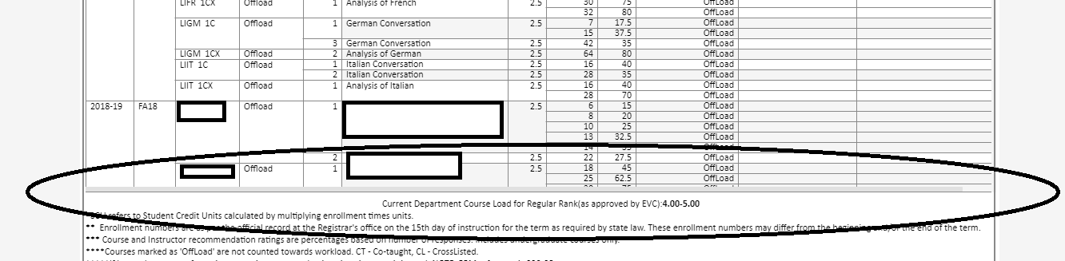

In rare cases, instructors may have too many courses listed under their name to fit within the preset window. Then, you may try printing the information for each year separately. Email ir@ucsd.edu if you have trouble or need assistance with generating .pdf files.

- What do Annual Scheduled Course Load and Individual Instruction stand for?

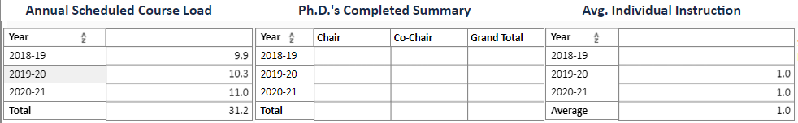

Annual Scheduled Course Load refers to the number of regular courses or independent studies with enrollment of 3 or more students taught by instructor in a given academic year. Detailed information can be found in table Scheduled Courses Taught.

Individual Instruction refers to the number of students who have taken independent/thesis studies with an instructor in a given academic year. Detailed information can be found in table Individual Courses Taught.

- What kind of enrollment counts are reported and how does enrollment correspond to Section ID?
Enrollment, units, and other course information here reported for a course offering (for example, CSE141L A and CSE141L B) and not an individual section. Course enrollments are counted based on Registrar’s records of student enrollment on the 15th day of instruction. A course offering includes all course components (discussions, labs, lectures, etc.). Each course component is assigned its individual section ID. Section ID reported in CLSD report is the section ID of the first course component. Frequently, the first course component is a no-credit section.

- How are the units counted?
Course units are corresponding to the units reported in the catalog and the units actually taken by the enrolled students.

- What if Department does not count particular course toward teaching credit or weighs it lower/higher than reported units?
CLSD report does not track differential “teaching credits” where a department may give various weights to particular courses. IR can only include data that comes from a campus data source, and departmental teaching weights are not kept anywhere centrally. The Department is always free to write an explanatory memo addressing this or other issues where official record does not match department’s account.

- If you have any other questions, please contact ir@ucsd.edu.

